The EU-LAC Digital Accelerator launches open call #4 for European, Latin American and Caribbean corporate-startup partnerships

- The EU-LAC Digital Accelerator invites partnerships to apply to its open call #4. Partnerships should involve a corporate entity seeking to address a digital challenge and a startup or SME developing a solution to address this challenge.
- For open call #4, the EU-LAC Digital Accelerator opens a new opportunity area: e-services. However, applications from all industries and digital specialisations are welcome.
- EU-LAC partnerships must include at least one corporate and one startup from two of the following regions: the European Union, Latin America, and the Caribbean.
- Selected candidates will receive acceleration services valued at up to €30,000 (€40,000 if a Caribbean partner is involved) and gathered around three pillars: proof of concept, business case, and investment and scaling.

Working on making corporate-startup partnerships true love stories

Following the MIT Sloane Management Review, it is estimated that 7 corporate-startup collaborations fail to reach the expected results. Misaligned cultures and objectives, the startup’s solution being unable to fit into the corporate’s IT environment, no product validation before scaling, etc. A huge number of factors can explain this dramatically high failure rate.

Through a dedicated corporate-startup acceleration programme, the EU-LAC Digital Accelerator supports cross-border partnerships between Europe, Latin America, and the Caribbean in reaching their innovation goals.

“Startups allow corporates to explore innovative solutions to their unsolved needs and problems. They provide unique insights not previously considered or tested. It ultimately has a real impact on the profit and loss statement, generating new revenue streams or saving costs.”

Miguel Rodríguez, Business Development, Octantis

To access the acceleration programme, corporate-startup partnerships must apply to the open calls organised by the EU-LAC Digital Accelerator.

Corporates and startups invited to solve e-services challenges (but not only)

Open call #4 for corporate-startup partnerships is open from 1 July 2025 to 31 October 2025.

Applying partnerships should include:
- A corporate facing an internal or customer-related challenge.
- A startup or SME providing a digital solution to this challenge.

For open call #4, the EU-LAC Digital Accelerator expands its focus to e-services.

E-services can refer to any commercial service that can be managed or completed electronically, without requiring physical presence. For instance:
- Fan engagement app for a football clubs:
Fans can interact with teams, answer surveys, receive merchandising offers, and access behind-the-scenes club content.
- Virtual exhibitions for museums:
Cultural institutions can offer virtual tours of their exhibitions on their websites and apps, enticing people to visit.
- Digital onboarding for bank customers:
With the use of AI, machine learning, and biometric verification, banks can let customers open accounts in a matter of minutes without them having to visit their local branch.

However, open call #4 is not restricted to e-services only, corporate-startup partnerships from any field are welcome to apply.

Once selected, partnerships will receive à la carte acceleration services

Taking a close look at the common challenges corporates and startups face when they work together, the EU-LAC Digital Accelerator designed a 6-month acceleration programme.

The programme focuses on three use cases:
- A corporate and a startup jointly develop a new product tailored to the corporate’s needs, leveraging the startup’s technological expertise.
- A startup integrates its solution to improve a corporate's process, validating its implementation and scalability
- One partner helps the other adapt a product and successfully enter and sell in its local market.

To solve these different scenarios, the EU-LAC Digital Accelerator grouped acceleration services around three pillars:
- Proof of concept, to validate the tech feasibility of the solution and ensure it answers a real need.
“We first support partnerships in reducing uncertainty when developing their innovation by conducting a proof of concept service to determine the feasibility of the project. Such a service demonstrates the strength of novel concepts and the challenges to overcome.”

Txomin Rodríguez, Product & Business Development, Octantis

- Business case, to build a business model that generates revenue and establish a winning international expansion strategy.
- Investment & Scaling, to produce and sell exponentially, and make the partnership ready to attract investments to improve the newly built solution.

Once selected, corporate-startup partnerships define - along with the accelerator’s experts - the most suitable services.

By the end of the programme, the partnership would have built a product or a service that solves a real problem and is nearly ready for commercialisation.

2025 novelty: up to €10,500 in grants for selected startups and SMEs to support proof-of-concept development and execution

In May 2025, the EU-LAC Digital Accelerator unlocked up to €10,500 of grants for selected startups and SMEs:
- €7,000 for proof-of-concept development.
- Up to €2,000 to travel to the corporate’s premises to run a proof of concept experiment.
- Up to €1,500 to transport the necessary equipment to test the solution.

Startups and SMEs can check their eligibility and apply for the grant by contacting their assigned mentor at the beginning of the programme.

The example of a Peruvian TV channel partnering with a Spanish startup

Latina TV is the second-largest Peruvian channel in terms of viewership, and it is struggling to keep its programmes out of illegal streaming platforms.

This has dire consequences:
- Piracy deprives Latina TV of revenue from legitimate subscriptions and advertising.
- Revenue losses hinder Latina TV’s ability to keep investing in high-quality productions.

On the other side of the Atlantic, Smart Protection is a Spanish startup with a mission: protect brands from counterfeits, piracy, and fake websites.

Through advanced semantic search and collaboration with social media platforms (such as TikTok and Dailymotion) and search engines, the partnership aims to develop a process for promptly identifying and removing illegal content.

This will allow Latina TV to redirect viewers to its official platforms, thus improving audience engagement and revenue.

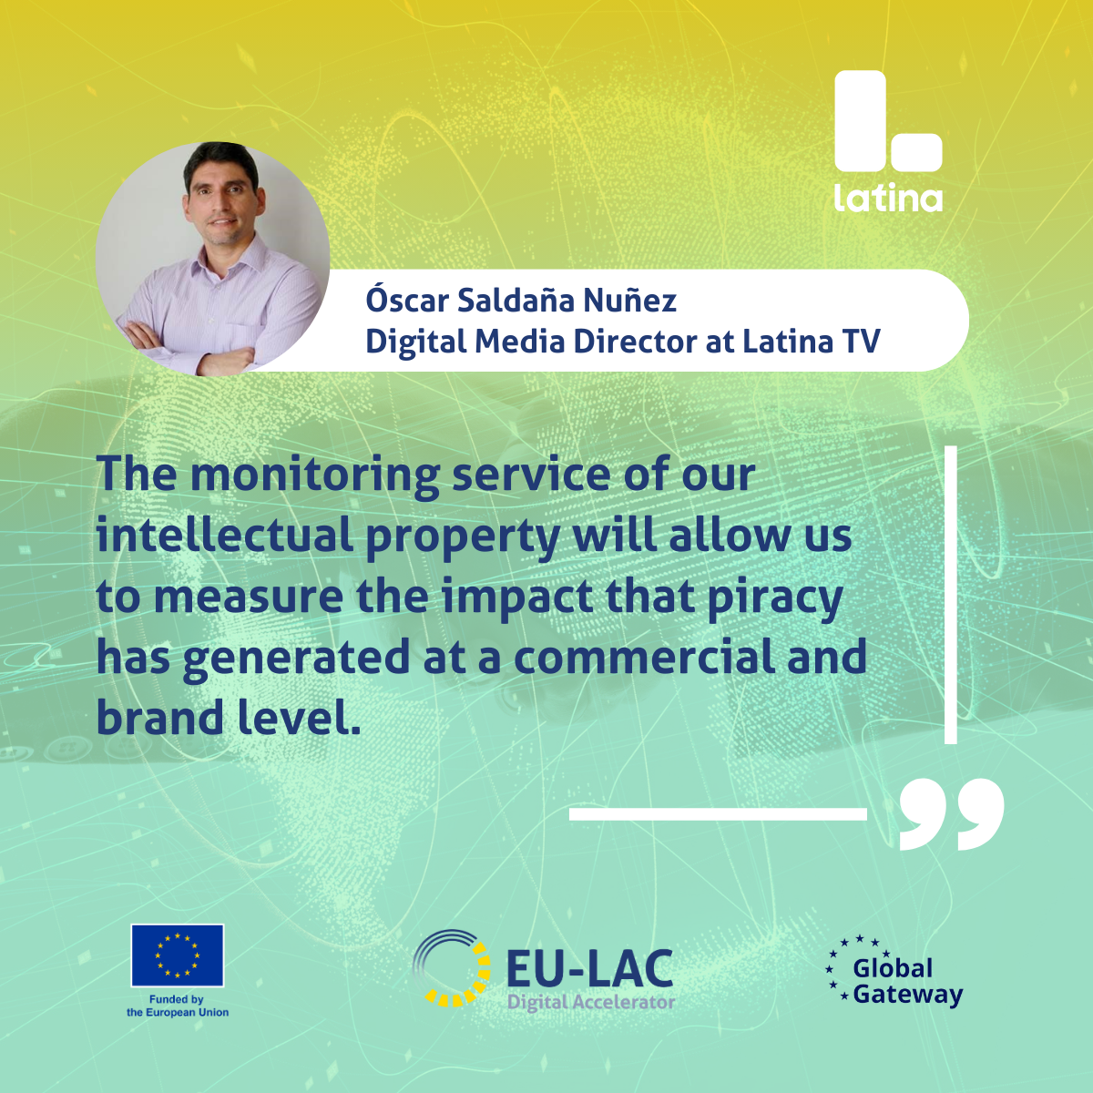 | 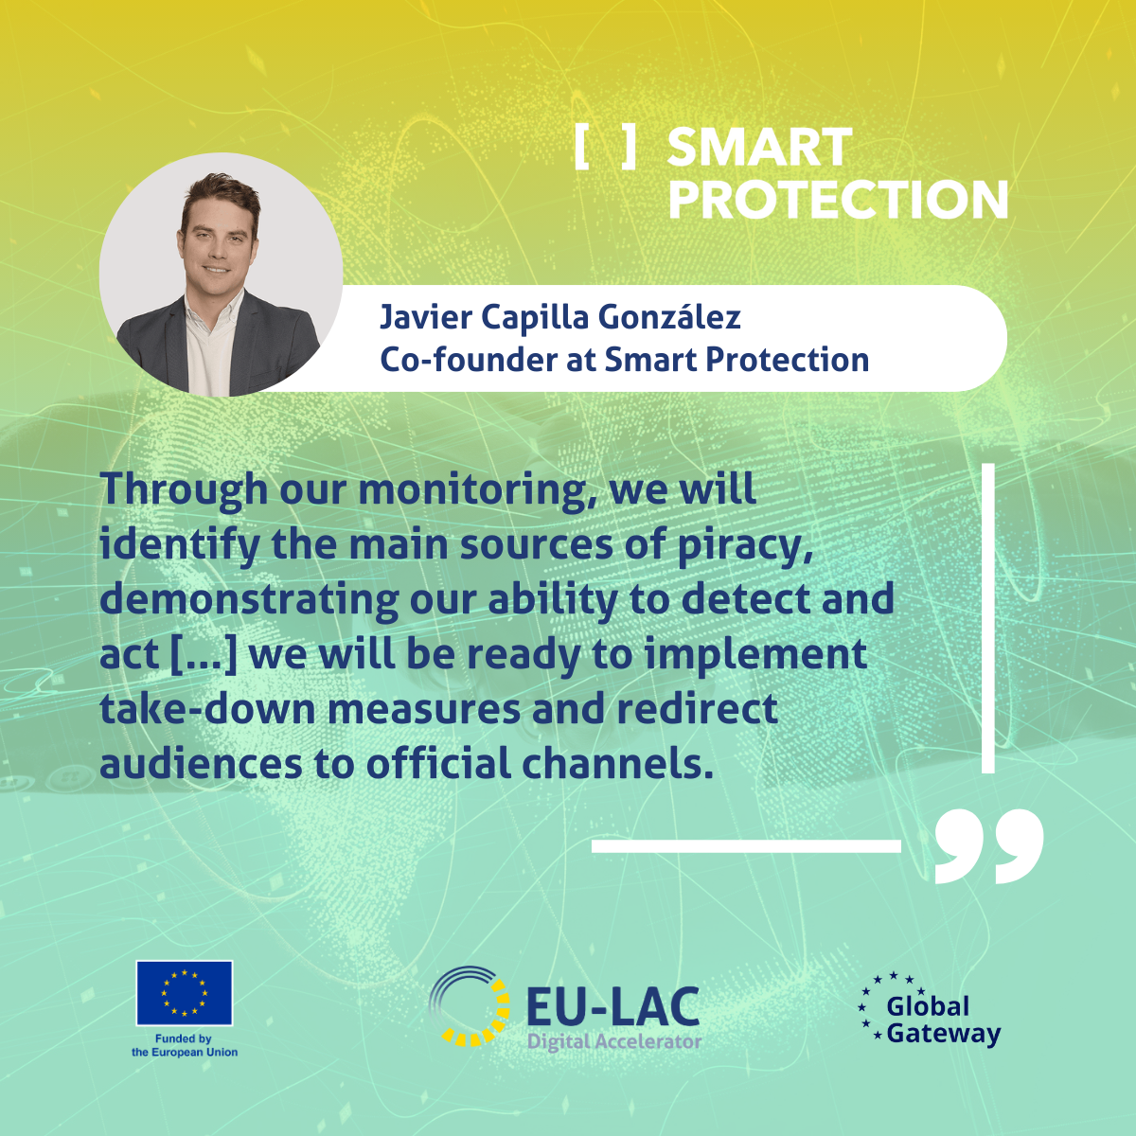

The internationalisation differentiator

The EU-LAC Digital Accelerator stands out as an accelerator for international partnerships.

In other words, the purpose of the accelerator is not only to make partnerships work on a product or service that can be commercialised, but also on a product or service that can be commercialised in a new market for one of the partners.

The Internationalisation & Soft-landing strategy service delivered by the accelerator answers this need by tackling regulation and tax issues as well as cultural aspects in order to “land” smoothly in a new country:

[VIDEO]

For this reason, applying partnerships must be located in distinct regions (the European Union, Latin America, and the Caribbean).

By way of illustration, a Caribbean startup would only be able to apply along with a European or Latin American corporate.

In order to help corporates and startups without a partner find an innovation mate, the EU-LAC Digital Accelerator has set up a matching platform.

With close to 60 corporate challenges and over 1,450 startups willing to bring their digital expertise, the matching platform has grown to become a strong marketplace where corporates and startups can get in touch and agree on a partnership before applying together to the open call.

Open call #4 summary

- Purpose of the EU-LAC Digital Accelerator: Support corporate-startup partnerships from the European Union, Latin America, and the Caribbean to build a digital product or service and bring it close to commercialisation.
- Application period: 1 July 2025 - 31 October 2025.
- Main eligibility criteria:
1) At least 2 applicants per application.
2) At least 1 corporate and 1 startup per application.
3) Applying corporate(s) and startup(s) must be from at least two of these three regions: EU, Latin America, Caribbean (applying corporate(s) and startup(s) cannot be from the same region).

- Matching platform (for corporates and startups who want to find a partner before applying to the open call and accessing the acceleration services).
- EU-LAC Digital Accelerator services:
- Proof-of-concept phase: Open Innovation bootcamps, Corporate Venturing capabilities, PoC Design & Prototyping, Reliability of AI solutions.
- Business case phase: Business model design, International growth and soft-landing, IP Management, Product roadmap & digital skills.
- Investment & Scaling phase: Scaling into corporate structures, Full process digitalisation, Investment Readiness & Matchmaking, Access to public funding.
- EU-LAC Digital Accelerator grants: Up to €10,500 for selected startups and SMEs for proof-of-concept development and execution.
- Application form & Information.

